Service-CNC Milling
Demo knowledge file for Content Studio | CNC Milling
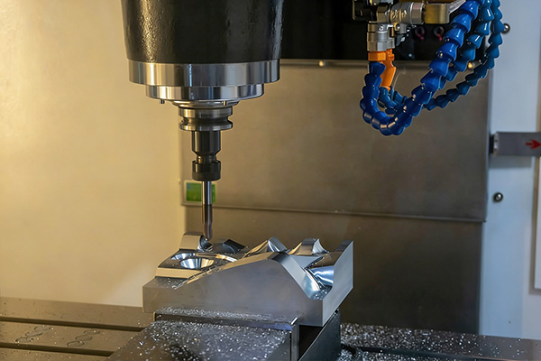
Representative image for CNC Milling service content.

Service Summary
Custom CNC milling service for housings, panels, brackets, molds, and precision structural parts.
We handle complex geometry parts with our 3-axis and 4-axis CNC milling. Ideal for aluminum, steel, and various metals.

Typical Applications
- Custom housings
- Heat-dissipating parts
- Brackets and panels
- Fixture components
- Precision structural parts

Material Coverage
- Aluminum
- Stainless steel
- Carbon steel
- Brass
- Copper

How Content Studio Should Use This File
- Use this service summary as source material for service pages, blog articles, landing pages, and RFQ-oriented email copy.
- Use the applications list to match service content with buyer scenarios and AI-generated article sections.
- Use the source URL when the generated content needs traceable evidence or a reference link.

Crawled Page Headings
- Service
- CNC Milling
- Find Content
- Explore
- Get In Touch
Source: https://www.rejincnc.com/service/cnc-milling/

